**Quantum Computing Module Student Questions**

## Qubits and the Bloch Sphere - Guided Inquiry Questions

1. Looking at the two Bloch spheres above, which of the six qubit states (|0⟩, |1⟩, |+i⟩, |−i⟩, |+⟩, and |−⟩) correspond to the spin-up (|α⟩) and spin-down (|β⟩) states in the spin-½ Bloch sphere? What do the remaining qubit states correspond to in the spin-½ Bloch sphere?
2. If the qubit were in one of the following qubit states, what would be the probability of measuring the qubit in the |0⟩ state?
   1. |0⟩
   2. |1⟩
   3. |+i⟩
   4. |−i⟩
   5. |+⟩
   6. |−⟩
3. If spin-½ particles were to be used for qubits, what spin-½ state would you use for the qubit initialization state, |0⟩?
4. If spin-½ particles were to be used for qubits, and all qubits were initialized in the quantum state |0⟩, list the pulses (e.g. 90X, 180Y) you could use to get a qubit in the following states:
   1. |1⟩
   2. |−i⟩
   3. |+⟩
5. Why do you think what you have learned thus far about NMR may be useful in understanding how to control, store, and recall information from qubits?

## Quantum Circuits and Single-Qubit Quantum Gates - Guided Inquiry Questions

1. Fill in the table below using the [Bloch sphere simulator](https://bloch.kherb.io/).

| Input | Gate | Output |
| --- | --- | --- |
| |0⟩ |  |  |
| |0⟩ |  |  |
| |0⟩ |  |  |
| |0⟩ |  |  |

1. Notice the path the qubit’s state vector (the blue arrow in the simulator) takes when operated on by the various gates. If you were using a spin-1/2 particle as a qubit, what pulses could you use to mimic the following gates:
   1. X

* 1. Y
  2. Z
  3. H (This is trickier than the others - look carefully at what axis the state vector is being rotated around!)

1. Using your NMR pulse analogues for the Pauli and Hadamard gates found in question 7, what outputs would you predict if the inputs in the table for question 6 were |1⟩ instead of |0⟩. Check your answer using the simulator. *Note: For checking your answer in the simulator, you need to now start the qubit in |1⟩, so consider what gate/s you can first apply to get the qubit into |1⟩ from its initialized state.*

| Input | Gate | Output |
| --- | --- | --- |
| |1⟩ |  |  |
| |1⟩ |  |  |
| |1⟩ |  |  |
| |1⟩ |  |  |

1. In your opinion, why might the Hadamard gate be particularly useful for quantum computations?
2. Using your NMR pulse analogues for the Pauli and Hadamard gates found in question 7, what would be the output for the quantum circuit model below if the qubit is initialized in |0⟩? Check your answer using the simulator.

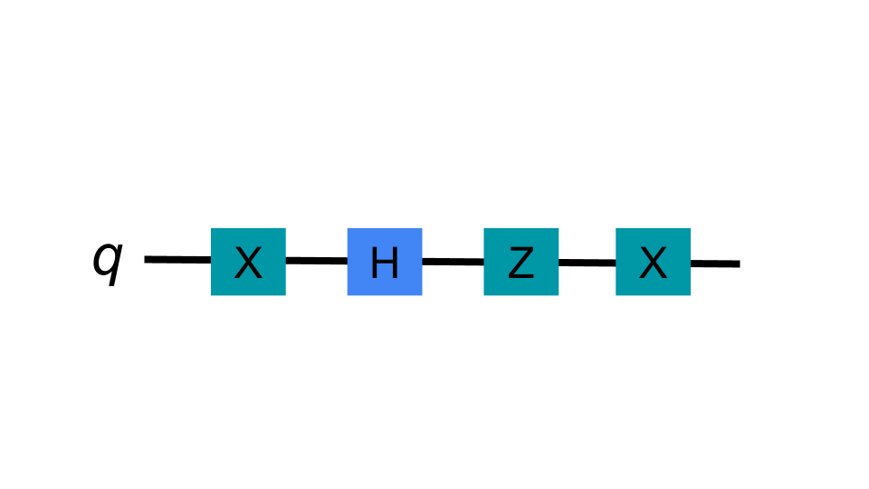

## Multiple Qubits - Guided Inquiry Questions

1. Suppose a two-qubit state is in the state:

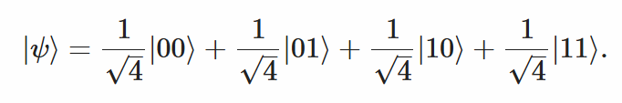

What is the probability of measuring |ψ⟩ in the following two-qubit states:

* 1. |00⟩
  2. |01⟩
  3. |10⟩
  4. |11⟩

1. Suppose a two-qubit state is in the state |ψ⟩ given in Question 11.
   1. If you were to measure just *q1*, what is the probability you would measure it to be in the state |0⟩? |1⟩?
   2. If you now measured qubit 1 to be in the state |0⟩, what is the probability that you would measure *q2* in the state |0⟩?
2. Suppose a two-qubit state is in the Bell state, |Φ+⟩. What is the probability of measuring the two-qubit system in the following states:
   1. |00⟩
   2. |01⟩
   3. |10⟩
   4. |11⟩
3. Suppose a two-qubit state is in the Bell state, |Φ+⟩ as in Question 13.
   1. If you were to measure just q1, what is the probability you would measure it to be in the state |0⟩? |1⟩?
   2. If you now measured qubit 1 to be in the state |0⟩, what is the probability that you would measure q2 in the state |0⟩?

## 

## 

## 

## Two-Qubit Quantum Gates and Entangled States

1. In your own words, use the logic table for the CNOT gate above to explain what the CNOT gate does.
2. If the control qubit is in a state such as |+⟩ and the target qubit is in |0⟩, what can you say about the output state of the target qubit after being operated on by the CNOT gate? Would this be an entangled state for the two-qubit system?
3. Determine the final state of the following circuit if q1 and q2 are both initially set to |0⟩. Anything special about this final state?

## Making Quantum Computing a Reality - Guided Inquiry Questions

1. Which two spin-1/2 nuclei in chloroform (and their isotopes) do you think would be good candidates for our two qubits?
2. How would you initialize both of these nuclei into the |0⟩ state?
3. If you wanted to put the qubits into the two qubit state |11⟩, draw the pulse sequence diagram you would use.
4. In order to entangle the spins through J-coupling, you would first need to get both spins precessing in the xy-plane of the Bloch sphere. Draw the pulse sequence you would use to achieve this.

## Reflection Questions

1. Read again the quote by Seth Lloyd at the beginning of this module. In your opinion, can the universe be considered a quantum computer?
2. Out of the various applications of quantum computing discussed, which are you most excited about? Why?
3. Quantum circuit models have some similarities with pulse sequence diagrams. Coincidence or not? Make your case.
4. A helpful review of what you learned in this module can be found in this [Quantum Enigmas introductory video](https://www.youtube.com/watch?v=yI-c30REP7s). Describe three concepts mentioned in the video and their NMR analogues covered in this module.

## Follow this rubric to assess your work for this module:

| **Scientific Ability** | **Adequate** | **Needs improvement** | **Inadequate** | **Missing** |
| --- | --- | --- | --- | --- |
| **Is able to provide key differences between classical and quantum computing** | Can identify multiple key differences between classical and quantum computing. | Can identify some key differences between classical and quantum computing. | Some of the explanations contain errors or are incorrect. | No attempt is made to provide key differences. |
| **Is able to use their understanding of spin dynamics on the Bloch sphere to find NMR analogues for single-qubit quantum gates** | Correctly found NMR analogues for all single-qubit quantum gates. | Correctly found NMR analogues for nearly all of the single-qubit quantum gates. | More than one NMR analogue for the single-qubit quantum gates is incorrect. | No NMR analogues for single-qubit quantum gates is provided. |
| **Is able to interpret quantum circuit diagrams and accurately predict the probability of different outputs for given inputs.** | Correctly interpreted and predicted the outputs for all the quantum circuit diagrams. | Correctly interpreted and predicted the outputs for most of the quantum circuit diagrams. | An attempt is made, but the interpretations and/or predictions of the outputs for the quantum circuit diagrams were mostly incorrect. | No attempt is made to interpret and predict the outputs for any of the quantum circuit diagrams. |